Legend
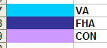

The following excel spreadsheet foreclosure tracking board 2014.xls, illustrates actions that need to be taken after we foreclose.

CONV

*1st legal: date that attorneys posted at the courthouse prior to foreclosure, this info resides in MS
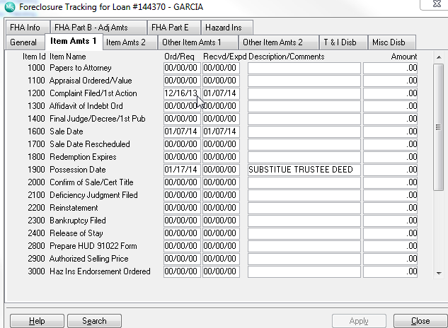
Metric: pick duedate and 1st legal needs to come in 5 months after due date if this is not the case we need to change color or provide an alert that first legal is beyond due date

*UPB:Unpaid Principal Balance, if foreclosre not final we pick the info from the ‘current principal balance” if paid off or foreclosed then we pick amount from “principal paid”

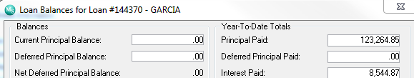

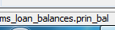
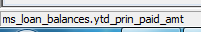

*F/C DATE
Date Foreclosed
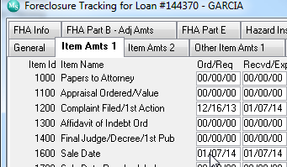
Line 1600 sale date ord/req
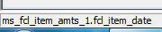

*REO Notice: once you foreclosed within 24 of foreclosured date fanniemae gets notifed in a form of an REO Gran Notice.

Metric : bucket should be created to list items that need to be notified to fanniemae once the loan is foreclosed servicing has 24 hours.

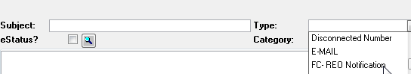

Let’s pickup create date

*Fannie Mae 571 Claim: We claim losses thru fannie mae.
Metric : we have 30 days of foreclosure date

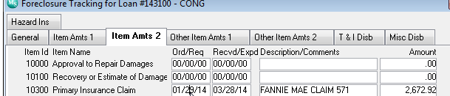
We pull the date from ord/req

*Fannie Mae 571 claim check: this is when we get reimbursement from fannie mae
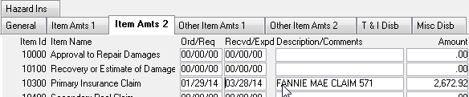
Here we need to ensure we have populated the received date

recvd/expd

*Claim Amount

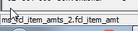 amount

*Supplemental Claim: if we are resubmitting a claim we will enter date here

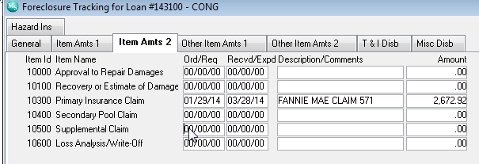
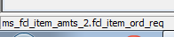

*Supplemental Claim Check date
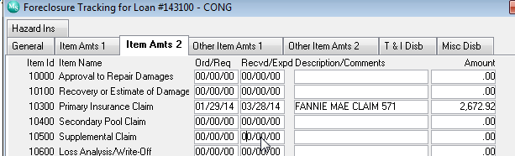

*Supplemental Claim Check Amount


